QuickBite Payment Gateway Reliability & Revenue Slippage — Capstone Project

Business Problem
QuickBite processes food delivery payments through multiple payment channels, including UPI, debit cards, credit cards, and cash. However, management needs better visibility into transaction failures, pending payments, and whether delivered orders have been successfully paid for.
Payment failures and unresolved pending transactions may delay cash collection, create reconciliation work, and affect customer experience. QuickBite therefore needs to evaluate payment channel reliability and identify transactions requiring follow-up.
Problem Statement
Payment Gateway Reliability & Revenue Slippage: Analyze settlement statuses across distinct payment channels (UPI, Cards, Cash) to detect transaction failure rates, pending cash flows, and overall settlement leakage.
Summary
The investigation covers payment status distribution, realized revenue, channel-level reliability, unpaid delivered orders, city-wise failed payments, customer segments, and payment channel rankings.
The dataset contains 43 Paid transactions, four Pending transactions, and three Failed transactions. The overall transaction failure rate is 6%, while the net order value associated with Paid transactions totals ₹39,805.75. A further ₹3,578.71 is associated with pending payments, and ₹2,860.27 is associated with failed payments.
Credit Card has the highest observed success rate at 100%, while Cash has the lowest at 72.73%. Debit Card generates the highest settled revenue at ₹11,849.13, reflecting its higher transaction volume. Most importantly, four delivered orders have non-Paid payment statuses, representing ₹3,809.21 in potential collection exposure.
The findings suggest that QuickBite should prioritize reconciliation of delivered but unpaid orders, investigate failed transactions, and monitor payment methods with higher observed failure or pending rates.

Dataset Overview
Metric | Result
Total transactions | 50
Paid transactions | 43
Pending transactions | 4
Failed transactions | 3
Overall failure rate | 6.00%
Net order value across all transactions | ₹46,244.73
Paid transaction value | ₹39,805.75
Pending transaction value | ₹3,578.71
Failed transaction value | ₹2,860.27
1. Gateway Settlement Overview
Objective: Measure transaction outcomes and quantify the order value associated with Paid, Pending, and Failed payment statuses.

1.1 Payment status distribution
Payment status | Transactions | Percentage
Paid | 43 | 86%
Pending | 4 | 8%
Failed | 3 | 6%
Total | 50 | 100%

Payment Transaction Status Distribution
Share of the 50 transactions by payment status.

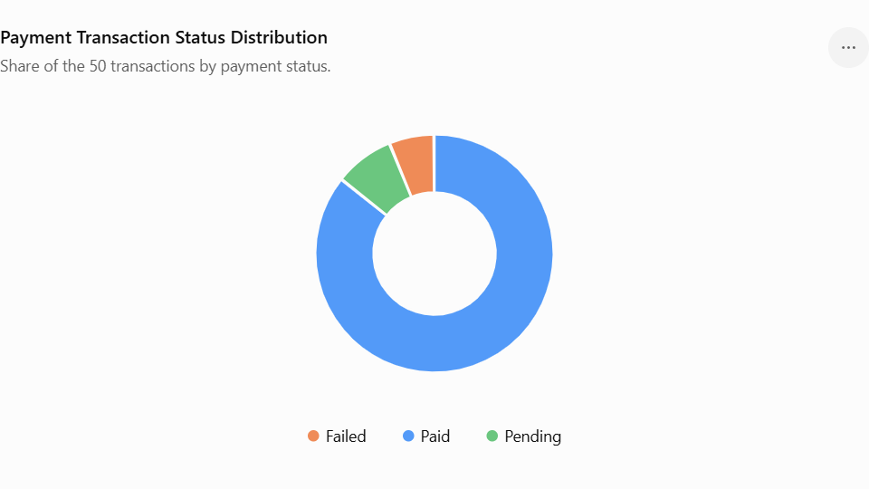

Analysis
- Paid transactions: 43 out of 50 transactions, or 86%, are marked Paid.
- Pending transactions: Four transactions, or 8%, have not reached a final Paid status.
- Failed transactions: Three transactions, or 6%, are marked Failed.
- The failed payment value is ₹2,860.27, while the pending payment value is ₹3,578.71.
The combined value associated with Pending and Failed statuses is ₹6,438.98, approximately 13.9% of the total net order value.

1.2 Revenue associated with payment status
Payment status | Associated net order value
Paid | ₹39,805.75
Pending | ₹3,578.71
Failed | ₹2,860.27
Total | ₹46,244.73
Business insight: Most transactions are marked Paid, but 14% remain Pending or Failed. The ₹6,438.98 associated with these statuses represents an amount requiring investigation, not confirmed financial loss.

2. Payment Channel Reliability Analysis
Objective: Compare transaction volumes, failure rates, success rates, and revenue performance across Cash, Credit Card, Debit Card, and UPI.
2.1 Payment method usage
Payment method | Transactions | Share of transactions
Debit Card | 15 | 30%
Credit Card | 12 | 24%
UPI | 12 | 24%
Cash | 11 | 22%
Total | 50 | 100%

Payment Method Usage
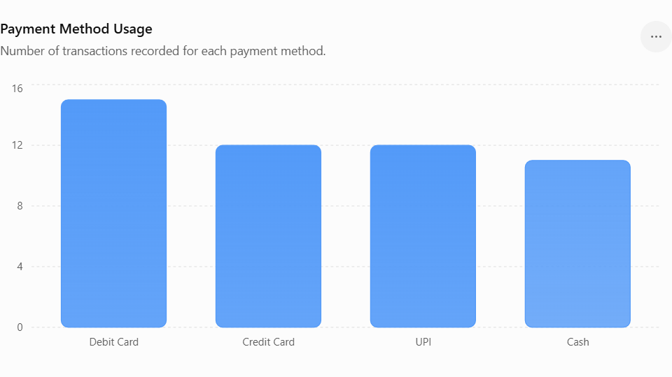
Debit card usage is high.
2.3 Reliability classification
Using your SQL thresholds:
- High Reliability: Zero failed transactions.
- Medium Reliability: Failure rate above zero but no greater than 8%.
- Low Reliability: Failure rate above 8%.
Payment method | Failure rate | Classification
Credit Card | 0.00% | High Reliability
Debit Card | 6.67% | Medium Reliability
UPI | 8.33% | Low Reliability
Cash | 9.09% | Low Reliability
Business insight: Credit Card has the strongest observed performance, while UPI and Cash exceed the 8% failure-rate threshold used in the project. Debit Card has the highest transaction volume and the highest settled revenue, but it also has two Pending transactions.
These rates are based on a small dataset, so they should be treated as initial indicators rather than definitive measures of long-term gateway reliability.

3. Operational & Fulfillment Discrepancies
Objective: Identify delivered orders whose payment status is Pending or Failed, and quantify the value requiring collection or reconciliation.
This section is especially important because a failed payment on an order that was never fulfilled is different from a payment problem on food that has already been delivered.

3.1 Delivered orders with non-Paid payments
Your SQL identifies four delivered orders with a non-Paid payment status.
Order ID | Payment method | Payment status | Net order value
2 | Cash | Pending | ₹1,106.11
35 | Debit Card | Pending | ₹709.90
42 | UPI | Failed | ₹377.86
45 | Debit Card | Failed | ₹1,615.34
Total |  |  | ₹3,809.21
Analysis
- Two delivered orders have Pending payments, representing ₹1,816.01.
- Two delivered orders have Failed payments, representing ₹1,993.20.
- The largest outstanding order value is ₹1,615.34, associated with a Failed Debit Card payment.
- The four orders represent potential collection exposure because the orders are marked Delivered but their payments are not marked Paid.

4. Customer & City Revenue Slippage
Objective: Determine where failed payment values are concentrated geographically and which customer segments are affected.
4.1 City with the highest failed payment value
City | Failed transactions | Failed order value
Ahmedabad | 1 | ₹1,615.34
Pune | 1 | ₹867.07
Delhi | 1 | ₹377.86
Total | 3 | ₹2,860.27
Ahmedabad has the highest failed payment value at ₹1,615.34, representing approximately 56.5% of all failed payment value.
Pune contributes ₹867.07, while Delhi contributes ₹377.86.
Business insight: Ahmedabad is the first location to investigate for the highest-value failed transaction. However, each city has only one failed transaction in this sample, so the results do not establish that Ahmedabad has a systematically higher failure rate.
4.2 Revenue slippage by customer segment
Customer segment | Failed transactions | Failed order value
Regular | 3 | ₹2,860.27
All three failed transactions belong to customers classified as Regular. No failed payment value is recorded for the Premium or New segments.
Business insight: Regular customers account for all failed payment value in this dataset. This is worth investigating, but it does not prove that Regular customers experience more payment problems overall. The number of transactions made by each segment must also be considered.
Recommendation: Examine the three failed Regular-customer transactions for common patterns, such as payment method or transaction value. Calculate segment-level failure rates before introducing segment-specific interventions.
4.3 Customers affected by failed payments
Customer | City | Payment method | Net order value
Siddharth Jain | Ahmedabad | Debit Card | ₹1,615.34
Nisha Gupta | Pune | Cash | ₹867.07
Rahul Verma | Delhi | UPI | ₹377.86
These customers represent the three failed transactions in the dataset.
Business insight: The failed transactions span three payment methods and three cities, so the available evidence does not point to a single payment channel or location as the exclusive source of failure.
Your query compares failed order values against the average net order value of ₹924.89.
Only one failed order exceeds this benchmark:
Order ID | Payment method | Net order value
45 | Debit Card | ₹1,615.34
The average value of a failed transaction is ₹953.42.
Business insight: Order 45 is a priority for investigation because its value is substantially above the average net order value. Its combination of a Delivered order status and Failed payment status makes it especially important to reconcile.
5. Payment Channel Revenue & Rankings
Objective: Compare payment methods by realized order value and transaction volume to understand their contribution to recorded Paid transactions.
5.1 Settled revenue by payment method
Payment method | Paid transactions | Paid order value | Revenue rank
Debit Card | 12 | ₹11,849.13 | 1
UPI | 11 | ₹9,656.19 | 2
Credit Card | 12 | ₹9,151.76 | 3
Cash | 8 | ₹9,148.67 | 4
Total | 43 | ₹39,805.75

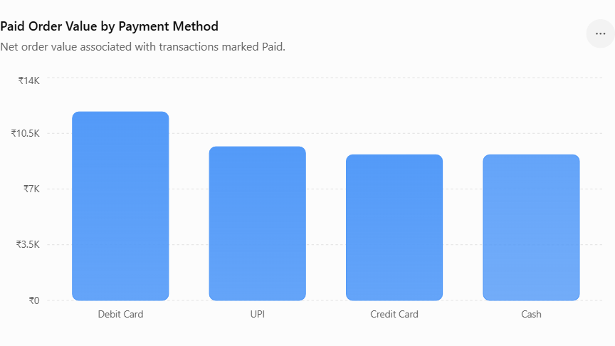
Analysis
- Debit Card generates the highest recorded Paid order value at ₹11,849.13.
- UPI contributes ₹9,656.19, ranking second.
- Credit Card and Cash generate similar Paid order values, at ₹9,151.76 and ₹9,148.67, respectively.
- Debit Card's leading position reflects both its 15 total transactions and the value of its Paid orders.
The ranking does not establish which payment method is most profitable, because transaction-processing fees and other payment-related costs are not available.
Business insight: Debit Card is the largest contributor to recorded Paid order value, while Credit Card has the strongest observed success rate. These are different measures: one reflects value, while the other reflects payment outcomes.
5.2 Payment channel ranking by volume
Rank | Payment method | Total transactions
1 | Debit Card | 15
2 | Credit Card | 12
2 | UPI | 12
4 | Cash | 11
Debit Card ranks first by transaction volume. Credit Card and UPI share second place.
5.3 Overall settlement and collection exposure
The combined value associated with Pending and Failed payments is:
Measure | Value
Total net order value | ₹46,244.73
Paid order value | ₹39,805.75
Pending order value | ₹3,578.71
Failed order value | ₹2,860.27
Pending plus Failed value | ₹6,438.98
This ₹6,438.98 should be described as unresolved payment-status exposure, not confirmed settlement leakage. Some orders may have been cancelled, payments retried, or cash collected outside the records.
The more specific measure for immediate operational follow-up is the ₹3,809.21 associated with Delivered orders whose payments are not marked Paid.
6. Strategic Recommendations
1. Payment reconciliation
- Prioritize the four Delivered orders with non-Paid payment statuses.
- Investigate order 45, worth ₹1,615.34, and order 2, worth ₹1,106.11.
- Verify gateway records, payment retries, refunds, and cash collection before classifying any value as a confirmed loss.
- Establish a daily reconciliation process between order records and payment records.
2. Payment channel reliability
- Investigate UPI failures, which account for an observed failure rate of 8.33%.
- Review Cash collection and recording procedures because Cash has the lowest observed Paid rate.
- Monitor Debit Card transactions, particularly the two Pending payments.
- Continue tracking Credit Card performance while collecting more transactions to establish a reliable long-term benchmark.
3. Revenue protection
- Create an exception report for Delivered orders with Pending or Failed payments.
- Prioritize reconciliation based on order value and fulfillment status.
- Track how many Pending transactions eventually become Paid, Failed, or refunded.
- Distinguish failed payment attempts from actual financial losses.
4. Customer and city monitoring
- Review the three failed transactions affecting Regular customers.
- Investigate the Ahmedabad transaction with the highest failed value.
- Calculate failure rates by city and customer segment using total transactions as the denominator.
- Avoid targeted policy changes based on only one or two transactions in a group.
5. Improve payment analytics
- Store gateway transaction IDs and settlement timestamps.
- Record payment retries and final transaction outcomes.
- Track processing fees, refunds, chargebacks, and confirmed settlement amounts.
- Monitor transaction failure and pending rates over a larger period.
Final Conclusion
The analysis reveals that 86% of transactions are marked Paid, 8% are Pending, and 6% are Failed. Credit Card has the highest observed success rate at 100%, while Cash has the lowest at 72.73%. Debit Card generates the highest recorded Paid order value of ₹11,849.13.
The key operational finding is that four Delivered orders have non-Paid payment statuses, representing ₹3,809.21 in potential collection exposure. Separately, ₹6,438.98 is associated with all Pending and Failed transactions, although this should not be interpreted as confirmed revenue loss.
Overall business outcome: The project provides a structured SQL-based assessment of payment reliability and identifies specific transactions, channels, and customer records requiring further investigation. By combining payment outcomes with order fulfillment data, QuickBite can improve its reconciliation process and reduce the risk of unresolved collections.

